**EXPERIMENT 1-DESIGN AN LED FLASHER**

**THEORY:**

**Concept used:- Led flasher is a simple circuit which will blink the LED’S in regular period of time. This circuit can be used for decoration purpose or can be used for a signalling purpose and many more.**

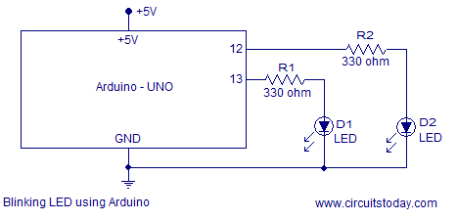

**Learning and observations:**

**From this experiment we learnt that we should make a proper circuit otherwise there will be a chance to get short.**

**We have to make proper connections then only our led will work.**

**If there will be a proper connection through the circuit the led will glow without any troubleshooting.**

**Proper coding is needed for led to glow.**

**Problems and troubleshooting:**

**Proper connections are needed otherwise there will be a chance to get short.**

**Sometimes the led’s which we are choosing may interrupt between the connections because sometimes they are not working properly so it may create a problem.**

**If our connection is not proper then it may destroy the led.**

**Precautions:**

**The normal working current of LED’s is 20mA thus even a small fluctuation in voltage ,say 0.1,can cause big fluctuation in electrical current (10-15% change).**

**The high electric current will cause the fast decline of burning out and luminance of LED.**

**When designing the PCB board, proper number and size of current-limiting resistors should be used to make sure the LED’S work in optional environment.**

**Learning outcomes:**

**From this experiment we learnt how to make circuit.**